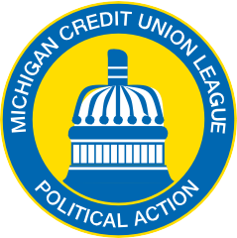
MICHIGAN CREDIT UNION LEAGUE LEGISLATIVE ACTION FUND

CREDIT UNION PERMISSION AGREEMENT

By signing below, this credit union hereby grants the Michigan Credit Union League Legislative Action Fund (MCULLAF) permission to communicate federal political action information to the credit union’s solicitable class. Credit union approval is necessary before the PAC may conduct a solicitation. The credit union grants its permission to MCULLAF for each of the years indicated below. The credit union has not approved a federal PAC solicitation from any other trade association for these years.

Print Name: _____________________________________________________________________
Title: ___________________________________________________________________________
Credit Union Name: _______________________________________________________________
Chapter: ________________________________________________________________________

Authorization:

2021___________________________________________________________________________
Year Print Name Signature Date

2022____________________________________________________________________________
Year Print Name Signature Date

2023_____________________________________________________________________________
Year Print Name Signature Date

2024_____________________________________________________________________________
Year Print Name Signature Date

2025____________________________________________________________________________
Year Print Name Signature Date

Please email the completed form to:
Email: Haleigh.Krombeen@mcul.org

